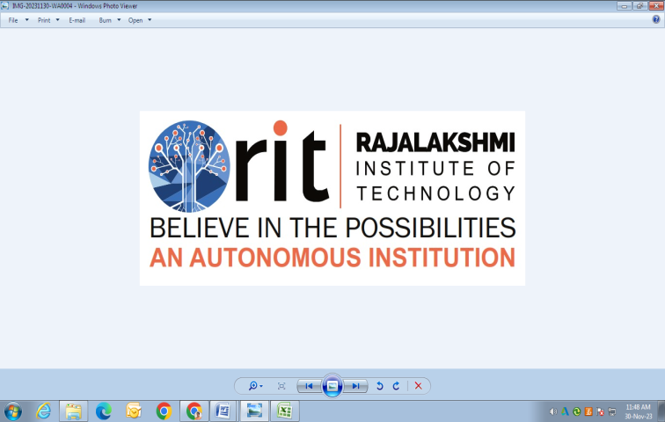
RAJALAKSHMI INSTITUTE OF TECHNOLOGY
(An Autonomous Institution, Affiliated to Anna University, Chennai)

DEPARTMENT OF ARTIFICIAL INTELLIGENCE AND DATA SCIENCE
ACADEMIC YEAR 2025 - 2026
SEMESTER III
ARTIFICIAL INTELLIGENCE LABORATORY
MINI PROJECT REPORT

REGISTER NUMBER | 2117240070309
NAME | SINDHUJA M
PROJECT TITLE | Energy Clash
DATE OF SUBMISSION | 03-11-2025
FACULTY IN-CHARGE | Dr. Bavani M

Signature of Faculty In-charge

INTRODUCTION
- Brief overview of Artificial Intelligence concepts.
- Clearly introduce the topic, provide background context, explain why the problem matters, and highlight what the project aims to accomplish.
PROBLEM STATEMENT
- Clear and Precise Problem Statement
GOAL
- Expected result and the possibilities for the given problem statement
THEORETICAL BACKGROUND
  - Theoretical Background about the problem statement as well as the algorithm.
  - Literature survey of the given problem and other possible algorithms
  - Justification for choosing the algorithm
ALGORITHM EXPLANATION WITH EXAMPLE
- Explanation of Algorithm with appropriate example
IMPLEMENTATION AND CODE
- Python code
OUTPUT
- Output Screen shots and explanation
RESULTS AND FUTURE ENHANCEMENT
- Possibility and comparison of your way of solving the problem with others.

Git Hub Link of the project and report | https://github.com/Sindhuja-M-309/AI_mini_project-3rd_sem_-.git
REFERENCES
- At least 5 Resources that you referred (May be books/on-line resources (E-Books, standard Videos and blogs Strictly no conversational agents like ChatGPT, Gemini etc.,)
Artificial Intelligence (AI) is one of the fastest-growing domains of computer science that enables machines to perform tasks that typically require human intelligence, such as reasoning, learning, perception, and problem-solving. The purpose of this mini-project is to demonstrate the use of AI in a strategic game environment.
The project “Energy Clash” simulates a competitive interaction between a human player and an AI opponent. Each participant is given limited energy (100 units), which must be distributed across five cells strategically. The AI uses a heuristic optimization approach — hill climbing — to improve its energy allocation with each round. This project provides a simplified yet insightful demonstration of how AI decision-making and optimization algorithms work in game-like environments.
The challenge addressed in this project is to develop an AI that can strategically allocate resources under constraints to outperform a human player. The AI must make near-optimal decisions in real time while adapting to past results. This involves an exploration of search algorithms, particularly hill climbing, to fine-tune allocation strategies. The human player, in contrast, manually distributes energy, offering a benchmark for evaluating the AI’s decision quality.
The goal of this project is to implement a game that highlights adaptive AI behavior using the hill-climbing optimization algorithm. The project aims to help students understand the concept of heuristic search, explore local optimization strategies, and compare AI decision-making with human intuition. The expected output is an interactive console-based game that declares the winner based on cell control and adaptive energy allocation.
Hill Climbing Algorithm:
The hill-climbing algorithm is a heuristic search method that begins with an arbitrary solution and iteratively modifies it to reach a better outcome. The algorithm evaluates neighboring solutions and moves toward the one with a higher score (better result). The process repeats until no improvement is found.
Advantages:
- Simple and intuitive algorithm.
- Fast for small-scale optimization problems.
- Easily implementable for real-time decision-making.
Disadvantages:
- Can get stuck in local optima.
- Does not explore global solutions unless randomness or restart is introduced.
Application in Energy Clash:
The AI agent uses hill climbing to slightly modify its previous energy allocation each round. These small changes (+5, 0, or -5) simulate local exploration while maintaining a constant total energy of 100. This allows the AI to gradually refine its distribution strategy and compete intelligently against the human player.
Algorithm Steps:
1. Initialize the AI’s energy allocations randomly across 5 cells.
2. Modify allocations slightly in each round by ±5 units.
3. Normalize total energy to 100 units.
4. Compare each cell’s energy against the player’s allocation.
5. The higher allocation wins the cell.
6. Repeat the process, updating the AI’s previous allocation for the next round.
Example:
If AI = [15, 20, 25, 10, 30] and Player = [10, 25, 20, 15, 30], then:
- Cell 1: AI wins
- Cell 2: Player wins
- Cell 3: AI wins
- Cell 4: Player wins
- Cell 5: Draw
This results in a tie. Over multiple rounds, the AI adapts its allocations to increase its winning probability.
The project is implemented in Python using object-oriented programming (OOP). The code defines two classes — Human and AI. The Human class takes user input for energy distribution, while the AI class automatically adjusts its strategy using hill climbing.
Technologies Used:
- Language: Python 3
- Modules: random
- Platform: Visual Studio Code
Key Functions:
- allocate_energy(): Handles energy distribution logic.
- resolve_battle(): Compares and declares cell winners.
- play_game(): Controls game flow and rounds.
GitHub Repository Link: https://github.com/Sindhuja-M-309/AI_mini_project-3rd_sem_-.git
Output:
The console displays the energy distribution of both the AI and human player, along with the outcome for each cell and the final winner.
Sample Output:
Cell 1: Player(20) vs AI(15) → Player Wins
Cell 2: Player(10) vs AI(25) → AI Wins
Cell 3: Player(30) vs AI(20) → Player Wins
Cell 4: Player(25) vs AI(30) → AI Wins
Cell 5: Player(15) vs AI(10) → Player Wins
Final Result: Player controls 3 cells, AI controls 2 cells → Player Wins!
(Insert screenshots here)
Results:
The AI demonstrates adaptive learning using the hill-climbing algorithm. It successfully competes with human strategies, showing noticeable improvement in energy distribution over rounds.
Future Enhancements:
- Develop a GUI using Tkinter or Pygame.
- Implement different AI difficulty levels.
- Add visual analytics using Matplotlib.
- Extend to multiplayer mode.
- Combine hill climbing with other algorithms like simulated annealing.
GitHub Link: https://github.com/Sindhuja-M-309/AI_mini_project-3rd_sem_-.git
References:
1. Russell, S. & Norvig, P., Artificial Intelligence: A Modern Approach.
2. GeeksforGeeks – Hill Climbing Algorithm.
3. W3Schools – Python Programming.
4. Python Official Documentation.
5. Towards Data Science – Game AI Tutorials.
6. TutorialsPoint – Python OOP Concepts.
7. Medium – Heuristic Search in Game Development.

